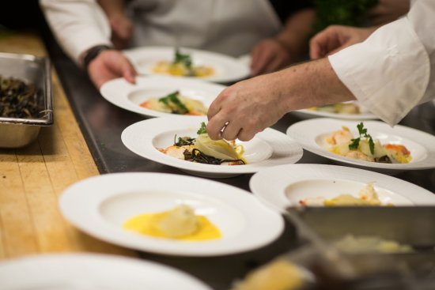
Pardon our dust.

Our recipes and menus are still being tested. Come back soon!

